Project Proposal

“Trip Planner”

By

Sehajdeep Kaur

Table of Contents

Client Detail……………………………………………………………………1

Project Proposal 2

Objectives 2

Project Description 3

Project Scope 4

Target Audience 5

Project Deliverables 5

Resource Requirements 6

Project Tasks 6

Assumptions of Project 6

Project Report 7

Detailed Design 8

Home Page 8

Login Page 8

My Trip Page 9

Detail of Trip 10

Testing 10

Summary 10

System Configuration 10

User Access Levels 10

# Client Detail

|  |  |
| --- | --- |
| Client Name | Balraj Singh |
| Project Name | Trip Planner |
| Email | Balrajsingh137@gmail.com |
| Contact | 028754453 |
| Lounch date | 17 Nov 2021 |

# 

## Section 1

## Task1

# Project Proposal

## Objectives

The objective of the final project is to create a trip planner organisation system using C# Entity Framework. The website will be using ASP.NET MVC 5. The aim of the website is to make it simple for the user to manage and or create upcoming trips.

## Project Description

The aim of the website is to make it easier for the user to organise their upcoming trips in one place. The user can have multiple trips, with multiple flights and other categories. When a flight for example is created the Trip Id is saved.

The website allows the user to add multiple trips. Under a trip, the user can add flights, car rentals, other transportation, lodgings, activities and restaurant reservations to the trip. Each of these categories can have multiple items added to it. On the details page of the trip, the user can view their flights etc. according to date. The user can edit, and update each of the categories. If the user is wanting to delete an item, the website takes the user to the delete page and confirms if they want to delete the item or not.

The user can add a person under a flight or one of the other categories under the trip. To do this the user needs to go to the details of for example the flight. Then the user can click the link add person. By clicking this link, the Id of the flight is saved and is used when adding the person.

The website will look attractive and well labelled, so that the user can easily use it. The website has been made so that it is easy for them to add, edit, and delete a trip, flights etc.

Under each trip in the details page, the days that the user is away is displayed. Under each day, the flights etc. are displayed if the date is the same as the flight date for example. Under the flight, if the user has added any persons, they will be displayed here.

This project is using Entity Framework in C# using ASP.NET MVC 5. I am using SQLite for the database backend. The project will follow the CRUD system.

When I started the project I started with two database tables: Trip and Flight. Once I got these two tables working well, I added the Person Table. At first I called it Passenger, but after thinking about it, I decided to call it Person as then could be used with more than just the Flight table. After the three tables were working, I added the following tables: Lodging, CarRental, OtherTransportation, ActivityTask and Restaurant.

Each table has a primary key Id. The following had a foreign key of TripId: Flight, Lodging, CarRental, OtherTransportation, ActivityTask, Restaurant and Person. The Person has a foreign key for each of the tables apart from Trip. The foreign key helps to connect two tables together and means I can retrieve data from another table.

## Task 2

## Project Scope

The scope of this project is to implement an application named as “Trip Planner” with the help of which user able to organise their upcoming trips in one place. The duration of the project is 20 working days which is equals to 4 weeks. But I had completed this project within 3 weeks.

Project Specifications

* User can add multiple trips with multiple flights and categories.
* User can add flights, Car rental, other transporation, Lodgings, Activities, Restaurant reservation to trip.
* Each Categories have multiple items to add.
* User can view their flight.
* User can edit, and update each of the categories.

## Target Audience

The target audience for this project is People who are Planning for trip to anywhere. In this web application people can add their day to day activities and make the advance reservation.

## Project Deliverables

The deliverables for the project are written below:

* Planning of Project

This includes the research of project and find resoucres how to create database. As well as linking for tables.

* Coding

Under this, We are executing the code of the project.

* Designing

After Completion of coding designing is implement on the application to look attractive.

* Demonstration and Testing

In this functionality is checked of whole application that it meet all the requriments of client.

Testing is also done to check the all functions and buttons are working properly.

* Documentation Of Project

In last, Documentation is done to tell about the web application and detail about it.

## Resource Requirements

Following technologies and development method:

* Asp.net MVC Framework
* Identity framework- ASP
* Windows Operating System
* 64-bit processor and 8 GB or more RAM

## Assumptions of Project

Following are the assumption made while implementing the project:

* Anyone can register with the application.
* Application will be free and open source.

# Project Report

#### Functional and Non-Functional

**Functionality of Project**

* Login/logout
* Register new person
* user can add, edit, delete and check details of trip

#### **Non-Functionality of Project**

* High speed
* Fast Loading time
* High performance and security
* All browsers compatibility.

## Task 3

# Detailed Design

## Home Page

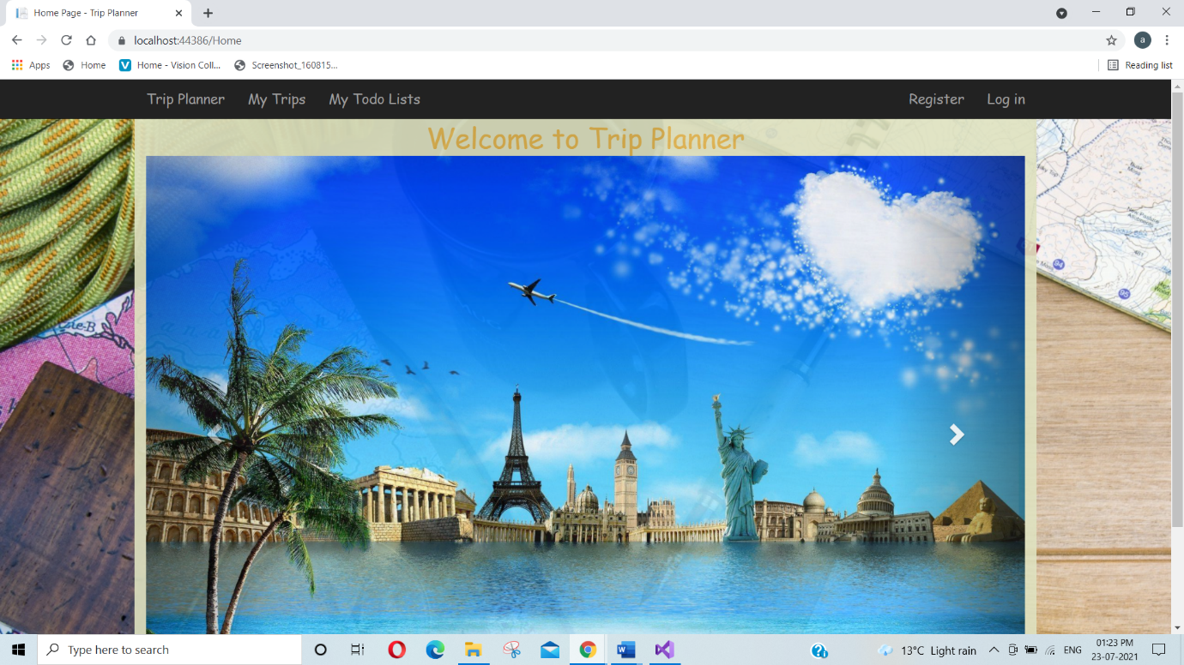This is the main page of the web application. This page contains Trip Planner, My Trip , My Todo, login, Register options on the navigation bar.

## Login Page

This Page will be used by the user to login into the system.

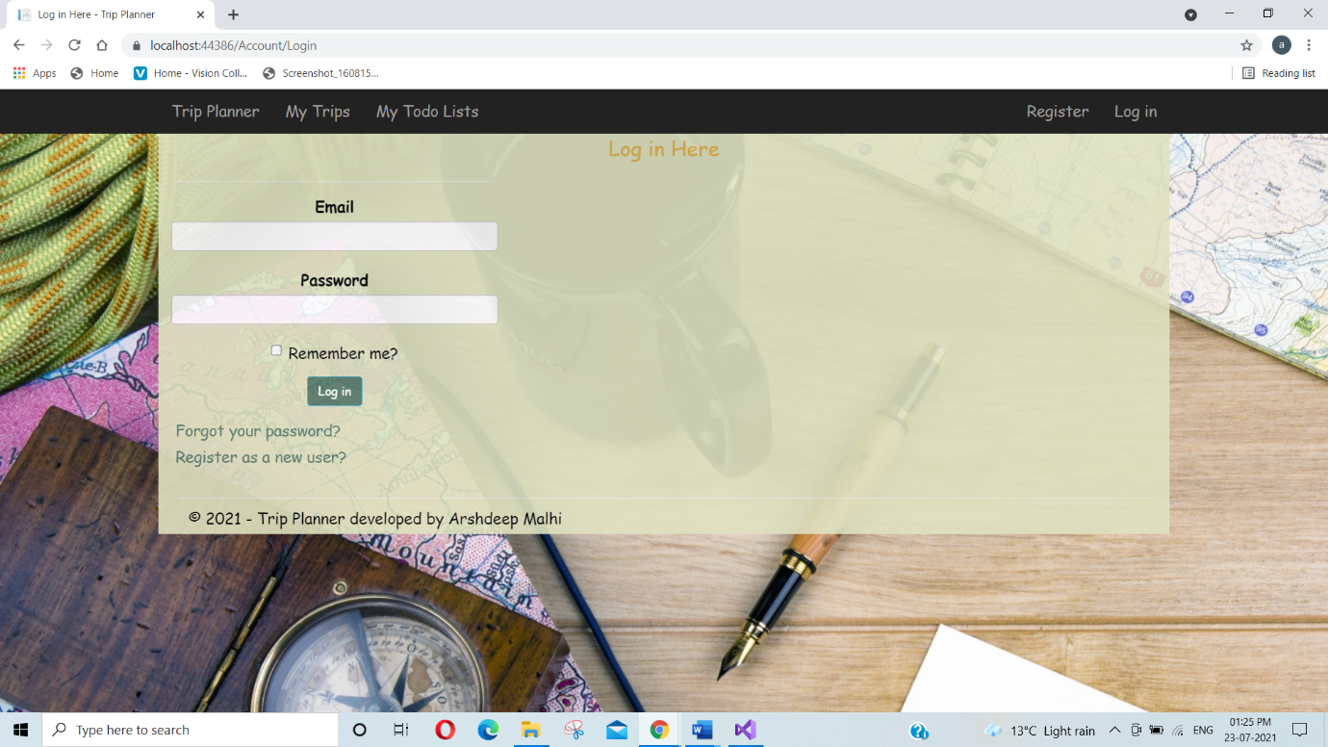

## My Trip Page

Here all the trips which are added display here.

## Detail of Trip

## Section 2

## Task 4

## Coding

All Coding file attached here <DSEDFinalProjectTripPlanner.sln>

**Task 5**

## Testing

The testing file for usability testing is attached as [Usability Testing.xlsx](Usability%20Testing.xlsx)

**Task 6**

## Meet with your client

My developer’s name: **Sehajdeep Kaur**

This form is intended to let you review the communication skills of your developer for this assignment. Your review will partly count towards their final mark. Do not take into account technical skills.

## Grading scale

You must grade your developer for each item listed in the tables below. 1 being the lowest, 5 the highest.

|  |  |  |  |  |
| --- | --- | --- | --- | --- |
| **1** | **2** | **3** | **4** | **5** |
| Strongly disagree | Disagree | Ok | Agree | **Strongly agree** |

## Review your developer

|  |  |  |
| --- | --- | --- |
| Item | Grade | Comment |
| Communicated clearly and effectively | A |  |
| Kept you informed of the progress | A+ | Always informed |
| Met timelines | B | Met timelines |
| Responded promptly to problems | A |  |
| Met overall project objectives | A | Yes |
| Was open to new ideas and suggestions | A | Always |
| Was easy to work with | A | Yes |

## Comments

Provide any extra comments on your developer’s communication skills and professionalism.

All the requirements done , Project run with no errors

**Signed by Client**

|  |  |
| --- | --- |
| **Signature: Balraj Singh** | **Date: 17/11/2021** |
| **Name: BalrajSingh** | **Title: Final Project** |
| **Contact details (email/Tel):** **balrajsingh137@gmail.com** | |

## Section 3

## Presentation and reflection

**Task 7**

Presentation

The Presentation file for project is attached as <Presentation.pptx>

**Task 8**

Software development life cycle

Phase 1: Application requirement analysis

The requirement collection and business is the first stage in the web and mobile application development process. It is performed by the senior team of business analysts, technical architects and project managers together with all the business stakeholders and domain experts in the industry.

* Scope definition of the entire project
* Planning for the quality assurance requirements
* Definition of anticipated issues, opportunities
* Recognition of the risks involved
* Timeline definition

Phase 2: Feasibility study

When the requirement analysis phase is done the next step is to define and document software needs in the 'Software Requirement Specification' ('SRS') document. It has everything which ought to be structured and created during the application development life cycle.  
‍  
There are main five types of feasibilities checks:

* Economic
* Legal
* Operation
* Technical
* Schedule

Phase 3: Design

Based on the SRS document the team prepares the system and software design to define the whole IT system architecture. This design phase will be a base for the next coding phase

Phase 4: Coding

The next phase is coding itself - the longest phase of the software development life cycle.   
  
Peculiarities of the phase:

* Developers should follow some predified coding guidelines.
* The whole development is divided into tasks for specific modules development.

### Phase 5: Testing

Once some part of the software coding is complete, it is sent for testing and the QA  team starts testing the functionality to verify that the application works following the requirements.  
  
The process is the following:

* QA team finds some issues;
* QA team sends them to the dev team;
* Dev deam fixes the issues;
* QA team rechecks the functionality.

### Phase 6: Deployment

Once the software is developed and fully tested, the final deployments process is launched.   
  
QA team checks the software on the production environment.

### Phase 7: Maintenance

After the release, the application continues its cycle following 3 possible ways:

* Bug fixing
* Software upgrade
* Enhancement with new features

**Task 9**

Project management

### Step 1. Initiation project life cycle

The first project management stage is initiation. Often considered the most important stage of project management, the [project initiation](https://kissflow.com/project/project-initiation/) phase includes all the preliminary work that must be done before any other project activities can take place. Exactly how many steps are in the initiation phase depends on what sector you’re in and how your team operates.

### **S**tep 2. Planning project life cycle

In the project planning stage, you flesh out the details of your project and create a successful [project plan](https://kissflow.com/project/steps-to-create-successful-project-plan/). *Those details can be divided into four broad categories:*

* Scope
* Resources
* Time
* Communication

### Step 3. Execution project life cycle

This is the phase most people have in mind when they think of project management. It usually starts with a [kickoff meeting](https://kissflow.com/project/project-kickoff-meetings/) to officially start off the project. This is when you share the vision and plan for the project, [delegating tasks](https://kissflow.com/project/team/how-to-delegate-tasks-effectively/) to team members, and send everyone on their way to get things done.

### Step 4. Monitoring project life cycle

It may be a bit counterintuitive to think of [project monitoring](https://kissflow.com/project/project-monitoring-and-controlling/) as a separate project management stage because it happens at the same time as the execution phase. Nevertheless, it’s helpful to identify monitoring as its own phase so that it’s not neglected.

### Step 5. Closure project life cycle

Closing a project involves obvious steps like delivering the product to customers and submitting final reports. The [project manager](https://kissflow.com/project/roles-and-responsibilities-of-project-manager/) must ensure that every aspect of the project has been correctly completed, all documents have been updated, and all deliverables have been formally accepted.